SSCA Expands Reach of its Marine HF Radio Service

By Dick Marsh (sv Bluebird)

This summer, SSCA will expand support of Marine HF radio nets to seasonal regional nets for the Chesapeake and southern New England, in addition to the Maine net of recent years.

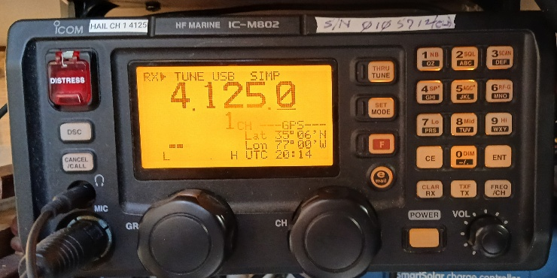

The seasonal nets will operate on separate frequencies at 0700 hours ET:

Chesapeake Bay: mid-May to end October: 4417 (4C)

Southern New England: mid-June to mid-September: 4149 (4B)

Maine: mid-July to mid-September: 4146 (4A) and 6227 (6B)

Marine HF radio nets enable cruisers to know who is nearby whom the cruiser may not otherwise know is nearby. Contact may even be the next boat in the anchorage. Plans can be made with friends. The nets are open to all cruisers.

The SSCA nets will be supported by AI feeds summarizing weather, navigation issues, and fun events of interest.

Seasonal nets serve the Bahamas, Caribbean and many other cruising areas with news as well as contacts. The SSCA seasonal nets follow the snowbirds into northern cruising waters and back.

SSCA and Ocean Cruising Club members have for several years quietly supported an 0700 net among Maine cruisers. SSCA lifetime member Russell Frazer has been the anchor boat for that net. In addition to the safety and check-in work, cruisers share news of concerts, fireworks, art shows, races, tall ships and their next anchorage.

Net time is 0700. The 4MHz band is relatively short distance – 200 miles +/-. The 0700 hour fits well with other morning HF and MF services reaching further (“MF” is marine HF):

0730 ET MF Chris Parker radio (and internet) US E Coast & W Atlantic

0745 ET HF WRCC – Waterway Radio – 7268MHz Chesapeake to Florida and Bahamas; ham only

0815 EDT MF KPK/Boatwatch 8104MHz Florida, Bahamas, Caribbean

0830 EDT MF Cruiseheimers 8152 MHz – Florida based; relays follow the snowbird migration to Chesapeake.

A basic net control script is posted on the SSCA website. In the absence of net control, anyone can initiate the net. Cruisers will know where to listen.

Will you be cruising north this season? Or living aboard locally? Or have a coast station? Could you help as part time net control for one or more nets?

If you can help as net control, or have any other question, please contact Dick Marsh at richardcmarsh@msn.com