Sugar Shack

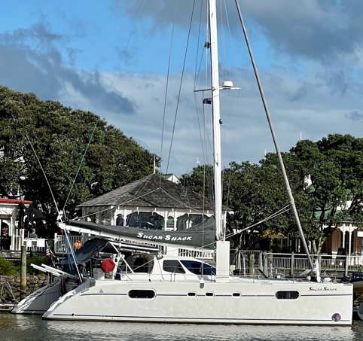

Sv Sugar Shack

Registration #1210280

Hailing Port: Austin, Texas, USA

Arrival Date: 18 April 2025

Departure Date: 25 April 2025

Captain: Matthew Mitchell

24 April 2025

To Whom it May Concern;

We are a visiting yacht registered in the United States. We arrived on Friday, 18 April 2025 and will be departing Funafuti, Tuvalu on Friday, 25 April 2025.

We are requesting Duty Free Fuel of 200 liters (50 gallons) to be purchased and picked up on Friday, 25 April 2025.

Our next port of call will be Savusavu, Fiji.

Thank you,

Matthew Mitchell, Captain, sv Sugar Shack